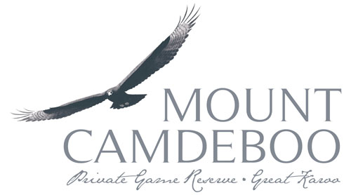

Hello!

Thank you for showing interest in our Conservation Experience. We look forward to hearing more about you. Please fill out the form and send it back to volunteers@mountcamdeboo.com

**Mount Camdeboo Volunteer Application Form**

|  |  |  |  |  |  |  |  |
| --- | --- | --- | --- | --- | --- | --- | --- |
| **Part 1: Personal Information** | | | |  |  |  |  |
|  |  |  |  |  |  |  |  |
| First Name: | |  | Last name: | |  |  |  |
|  | | |  | | |  |  |
| Date of Birth: | |  |  |  |  |  |  |
|  | | |  |  |  |  |  |
| E-mail address: | |  | Gender: |  |  |  |  |
|  | | |  | | |  |  |
| Home street address: | | |  |  |  |  |  |
|  | | | | | |  |  |
| City: |  |  |  |  |  |  |  |
|  | | |  |  |  |  |  |
| State or Region: | |  |  |  |  |  |  |
|  | | |  |  |  |  |  |
| Postal Code: | |  |  |  |  |  |  |
|  |  |  |  |  |  |  |  |
| Country: | |  | Country of Citizenship: | | |  |  |
|  | | |  | | |  |  |
| Home Phone: | |  | Cellphone: | |  |  |  |
|  | | |  | | |  |  |
| Primary Language: | | | Other Languages: | | |  |  |
|  | | |  | | |  |  |
| Allergies: | |  |  |  |  |  |  |
|  | | | | | |  |  |
| Are you currently taking any medication? If yes, please state what you are taking. | | | | | | | |
|  | | | | | |  |  |
| Special dietary requirements: | | | |  |  |  |  |
|  | | | | | |  |  |
| Emergency Contact Number: | | | |  |  |  |  |
|  | | |  |  |  |  |  |
| Emergency Contact Person: | | | |  |  |  |  |
|  | | | |  |  |  |  |
| What is their relation to you? | | | |  |  |  |  |
|  | | |  |  |  |  |  |
| Medical Insurance Carrier & Number: | | | | |  |  |  |
|  | | | |  |  |  |  |
|  |  |  |  |
|  |  |  |  |
| Travel Insurance Company & Contact Details: | | | | | |  |  |
|  | | | | | | |  |
| How did you hear about Mount Camdeboo Conservation Experience? | | | | | | | |
|  | | | | | | |  |
| Describe the state of your health and physical fitness: | | | | | | |  |
|  | | | | | |  |  |
|  |  |  |  |  |  |  |  |
| **Part 2: Education/ Interests** | | | | | |  |  |
|  |  |  |  |  |  |  |  |
| What is your highest level of Education? If tertiary, list qualification. | | | | | | | |
|  | | | | | |  |  |
| Awards/ Achievements: | | |  |  |  |  |  |
|  | | | | | |  |  |
| Please describe your ethos, hobbies, experiences and strengths: | | | | | | | |
|  | | | | | | | |
|
|
|
|
|
|
|
|
|
|
|
| Have you travelled abroad previously? If yes, to what countries? | | | | | | | |
|  | | | | | | |  |
| Have you been on a game reserve before? If yes, where? | | | | | | |  |
|  | | | | |  |  |  |
|  |  |  |  |  |  |  |  |
| **Part 3: Info about your Volunteer Experience** | | | | | | | |
|  |  |  |  |  |  |  |  |
| How long do you want to volunteer for? | | | | |  |  |  |
|  | | | | | |  |  |
| Preferred start date? | | |  |  |  |  |  |
|  | | | | | |  |  |
| What has motivated you to apply for the Mount Camdeboo Conservation Experience? | | | | | | | |
|  | | | | | | | |
|
|
| What do you believe you can contribute and what would you like to learn at MCCE? | | | | | | | |
|  | | | | | | | |
|
|
| What are your goals for wanting to volunteer at MCCE? Be as specific as possible. | | | | | | | |
|  | | | | | | | |
|
|
|  |  |  |  |  |  |  |  |